1. **Bank guarantees:**This is to view details of bank guarantees of the work package..

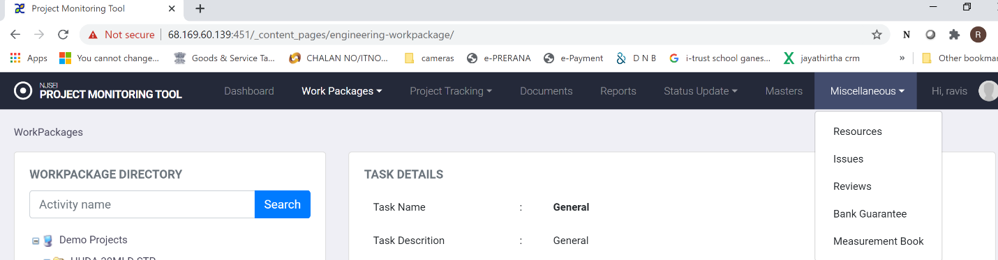

1. Choose “Miscellaneous” in main menu.
2. Click on “Bank Guarantees”.
3. You will see following screen.

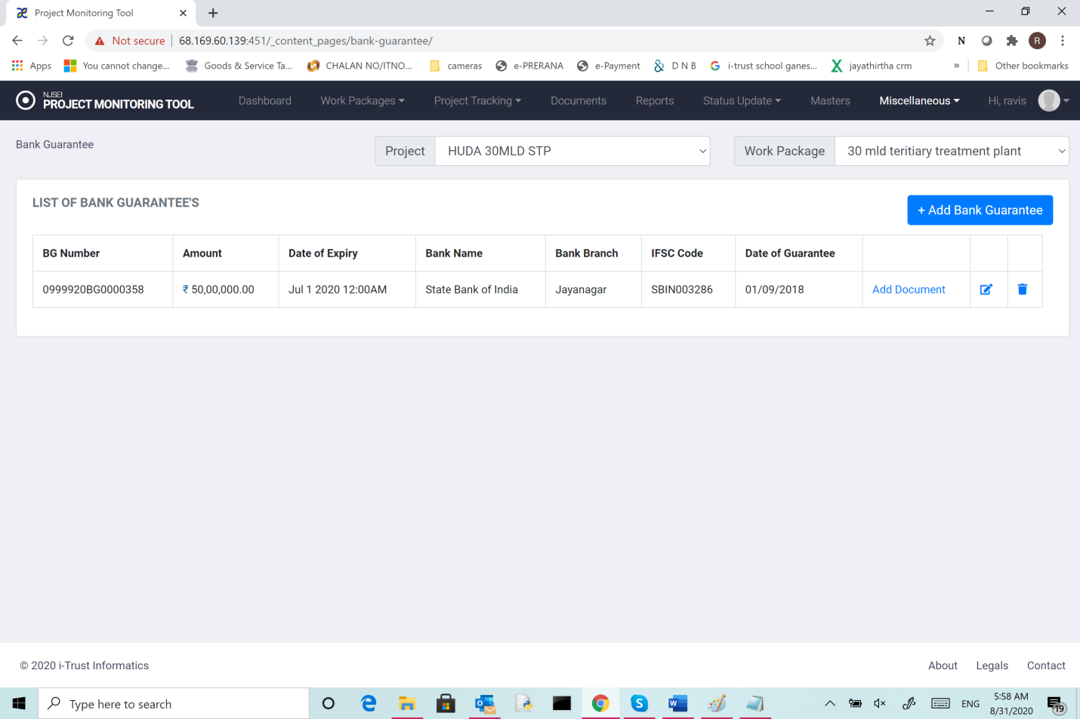

Show following details

1. BG Number,
2. Amount,
3. Date of expiry,
4. Bank name,
5. Bank branch name,
6. IFSC code,
7. Date of issue of bank guarantee
8. And scanned copy of the guarantee.

**11.1 Add Bank guarantees:**

1. Choose “Miscellaneous” in main menu.
2. Click on “Bank Guarantees”.
3. In the screen you see (shown above), click “Add Bank Guarantee”.
4. You will see following screen.

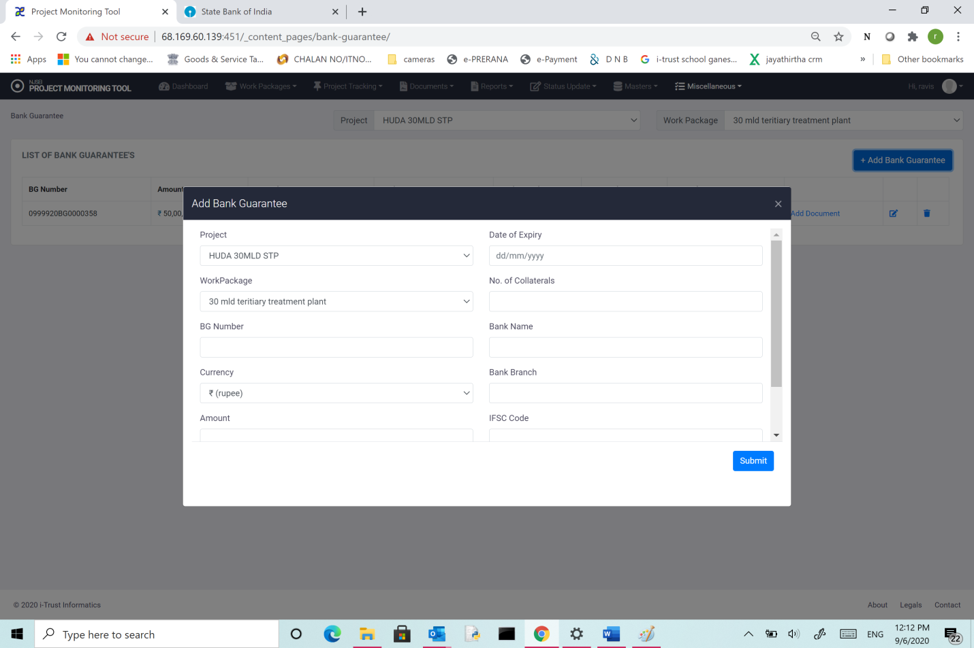

1. Choose project,
2. Choose “Work Package”
3. Enter BG Number,
4. Choose Currency,
5. Enter the Amount,
6. Enter Date of expiry,
7. Enter Bank name,
8. Enter Bank branch name,
9. Enter IFSC code,
10. Enter Date of issue of bank guarantee
11. And scanned copy of the guarantee.

Click “Submit”.

After the list is updated, Click “Add document” to add any scanned copy of the guarantee.